2023 INFORMS Blue Summit Supplies Data Mining Challenge: Pricing Analytics & Optimization for eCommerce Decision-Making
Anubhav Shankar
anubhavshankar1993@gmail.com

Abstract — In the rapidly evolving world of eCommerce, strategic pricing plays a crucial role in driving profitability and competitive advantage. Accurate pricing influences consumer behavior and impacts a company's bottom line. In industries with fierce competition and dynamic pricing, such as eCommerce, finding the optimal price for a product becomes a complex yet essential task. This task becomes even more significant considering the large volume of data generated through various eCommerce activities, providing a rich source for data-driven decision-making. Leveraging this data for pricing analytics and optimization can result in improved decision-making processes, increased profitability, and enhanced business growth.
Recognizing the importance and the challenges of Pricing Analytics and Optimization for eCommerce Decision-making, we have partnered with Blue Summit Supplies (BSS), a company that sells office supply products online. Based in Huntsville, Alabama, USA, BSS is continuously seeking innovative methods to maximize its profit. One of the significant challenges BSS faces is determining the optimal selling price for a large quantity of products in a market where prices can change daily or even hourly. Understanding the relationship between product prices and profits is highly desirable, which involves analyzing historical data and experimenting with real-time prices, a process that can take weeks.
Given the dynamic pricing strategies of market competitors, it's crucial for the company to analyze and respond to the market quickly and make prompt optimal pricing decisions. Through collaboration with BSS, the data challenge is aimed to call for novel data-driven solutions for the pricing analytics and optimization problem using BSS eCommerce data.
Keywords — eCommerce, Supervised Learning, Optimization, Pricing Analytics, Data Mining

MOTIVATION
This undertaking aims to achieve the following objectives:

- Determine the optimal selling price for an eCommerce product by leveraging more than two years of
historical data comprising various sales and market variables.

- Predict the expected daily profit for that product given a determined optimal selling price.

The developed solution should ideally lead to more profitable pricing decisions and strategies in a dynamic eCommerce market.

INTRODUCTION – Data source

Dataset
The training dataset contains a large collection of data for more than 200 different office products sold on the BSS eCommerce platform over a period of two and half years (01/01/2021 – Present).

Dataset Specifications
Here's a brief description of the variables in the dataset:

Variable | Definition | Key
Sku | This is the product ID | A unique identifier for each product.
salesdate | The date on which a particular product was sold
price | The price at which the product was sold on a given day
unitsordered | Shows the number of units of a product ordered on a particular day | It has been renamed to ‘volume’ in my script for the analysis
sales | Represents the total revenue generated from the sale of a product on a given day | It is calculated as the product's price times the number of units ordered.  Renamed as ‘revenue’ for analysis purposes
cogs | The direct cost incurred by the company to  produce or purchase the product | Stands for "Cost of Goods Sold"
fba | eCommerce fee associated with selling the product | Includes the costs of storage,  packing and shipping handled by Amazon
adspend | The advertisement cost associated with the product
reffee | eCommerce platform fee associated with selling the product | 15% of sales
profit | The profit obtained from selling the product | profit = sales – cogs – fba – reffee – adspend
managed_fba_stock_level | Represents the available quantity of the product in stock | Renamed as ‘stock’ for analysis purposes
comp_x_price | Represents the price of a similar product sold by a competitor | Up to 5 competitors' price data are available for each product
comp_data_min_price | Minimum price among all competitors for a similar product
comp_data_max_price | Maximum price among all competitors for a similar product
min_price | Minimum allowable selling price for the product
max_price | Maximum allowable selling price for the product

TABLE 1: DATASET SPECIFICATIONS

METHODOLOGY
A cursory glance through the abstract and the motivation sections might preordain using either a linear regression or a numerical method like extrapolation for the first objective and, consequently, use something like an Autoregressive Integrated Moving Average (ARIMA) for the second objective.

However, the methods above may fail to capture each product's inherent volatility and dynamic demand curves. So, a hierarchical/mixed effect model is more suitable for such a purpose. Additionally, a parametric model will be less computationally intensive and more intuitive.

Abbreviations and Acronyms
The following abbreviations will be used extensively throughout the document for brevity:
- ME -> Mixed Effect
- ARIMA -> Autoregressive Integrated Moving Average
- LME -> Linear Mixed-Effect
- OLS -> Ordinary Least-Squares
- RE -> Random Effect (can be used interchangeably with (i) & (iii))
- FFSKU47 -> File-Folders SKU 47

Initial Insights
Before we get into the application and understanding of ME models. Let’s briefly examine a few insights gleaned from the provided dataset. Let’s start by seeing the quarterly profit and monthly sales distribution for 2022.

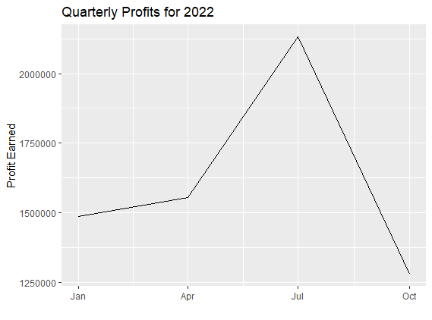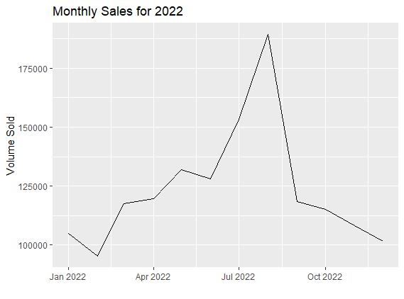

The figures above show that sales and profits fell sharply around the end of August. For more granularity, the volume sold has also been plotted on a weekly basis below. The graph below shows that the sales distribution is nearly normal, with Saturday as the worst-performing day. Such nuances will be useful to control for.

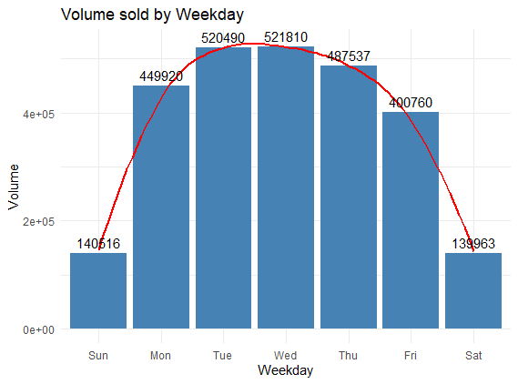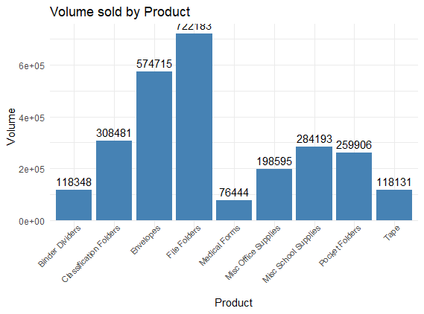

Additionally, there are nearly 230 individual products that are sold. However, they can be grouped into nine (9) distinct types/categories, as shown in the graph above that tracks the sales performance of each category. ‘File Folders’ is the best-performing product type/category.

Concurrently, we also know that each product can have multiple competitors. Let’s visualize the number of competitors per product category to get a bird’s eye view of what we can expect.

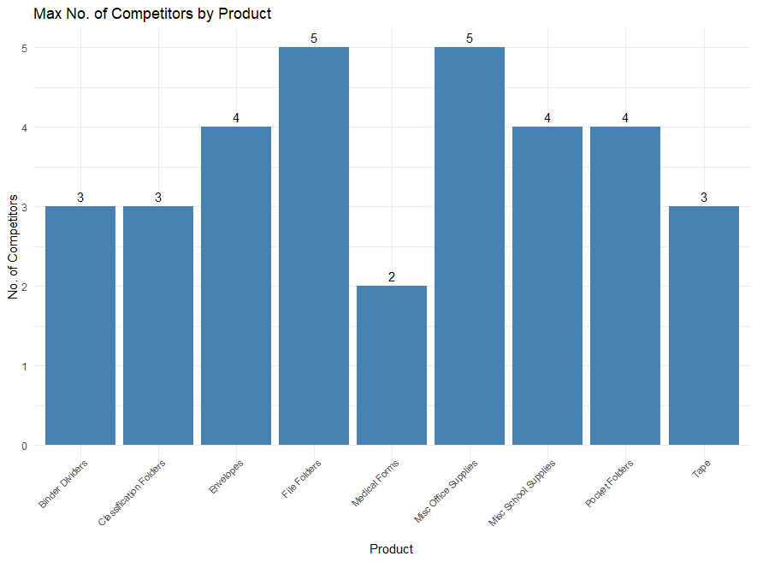

In addition to being the best-performing product category, ‘File Folders’ also has the highest number of competitors. While these overarching insights are useful, let us dive deeper and see the demand curves for the ‘File Folders’ category and our assigned ‘sku’, ‘File Folders SKU 47.’
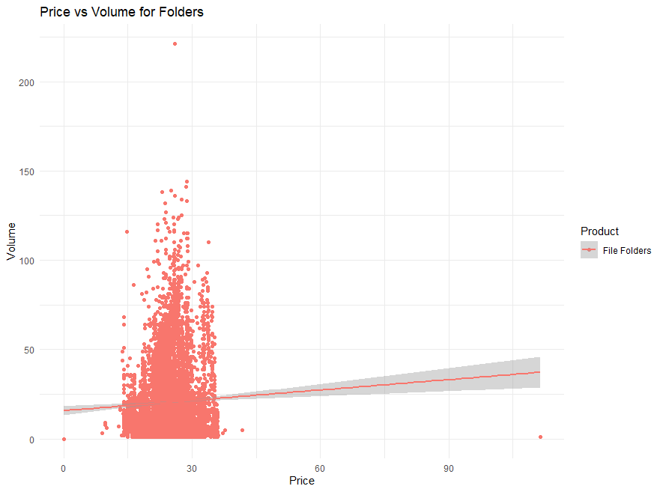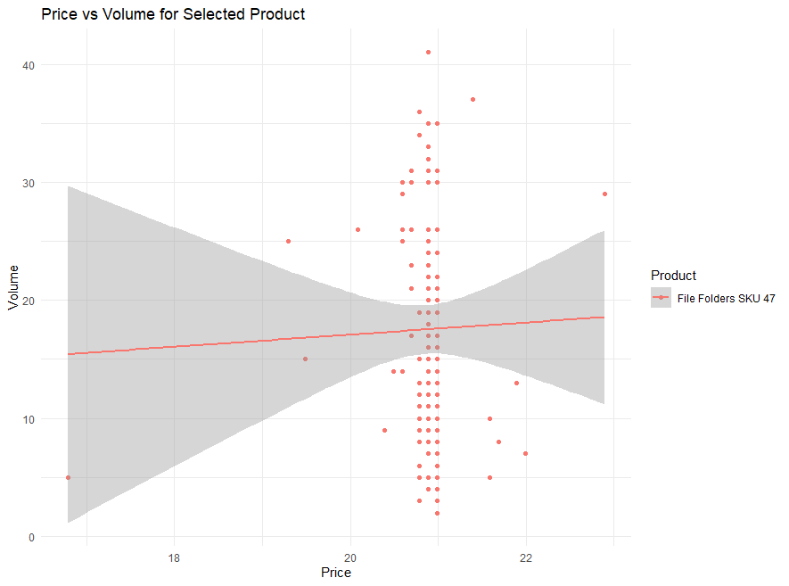
Figure 6: Demand Curve for Classification Folders Figure 7: Demand Curve for File Folders SKU 47

Right away, we observe a nuance. While the demand curve for ‘File Folders’ as a category shows a nominal spread with a noticeable upward slope, the curve for FFSKU47 shows a higher spread and has a practically flat slope.

Mixed Effect Models & Approach
Also known as Linear Mixed-Effect models, it is primarily used for modeling a mixture of fixed and random effects. Fixed effects refer to the typical main effects one would see in a linear regression model, i.e., the non-random part of a mixed model. In some contexts, they are referred to as the population average effect. Random effects are simply those specific to an observational unit, however defined. In our case, the observational units would be the products themselves.

In R, the lmer() command, part of the ‘lme4’ package, can be used to run a ME model. We will create an ME model to predict the optimal volume and then optimize it using the optim() command in the lme4 package to get an optimal price point. This predicted volume and optimal price point will then be used to obtain the revenue from which the static costs will be subtracted to get the optimal profit for the requisite time period.

Mathematically,

Volume =β₀ + β₁ * X₁ + β₂ * X₂ + β₃ * X₃ ₊ β₄ * X₄ + β₅ * X₅ + β₆ * X₆ + β₇ * X₇ + ε_{i} - (1)

In Eq(1), X₁, X₂, …… X_{n} -> The independent variables on which the dependent variable, ‘volume,’ will be modeled.

ε_{i} -> The error/residual term

where,
X₁ -> comp_1_price
X₂ -> comp_2_price
X₃ -> cost
X₄ -> Markup; coded as I(price-cost)
X₅ -> salesdate
X₆ -> weekday
X₇ -> RE of cost for each ‘sku’; coded as (1 + cost | sku), the ‘1’ represents the intercept for the RE

We’ll see the results and our prediction accuracy in Section IV.

EVALUATION & RESULTS

Final Results

RESULTS & FUTURE SCOPE

Acknowledgements

References

- https://www.r-bloggers.com/2021/01/machine-learning-with-r-a-complete-guide-to-logistic-regression/
- https://rpubs.com/zheshuen/596809
- https://www.kaggle.com/competitions/titanic/discussion
- https://www.r-bloggers.com/2013/09/roc-curves-and-classification/
- https://online.stat.psu.edu/stat462/node/207/
- https://www.wolframalpha.com/input?i=sigmoid%28x%29
- https://stats.stackexchange.com/questions/105501/understanding-roc-curve/105577#105577
- https://towardsdatascience.com/predicting-whos-going-to-survive-on-titanic-dataset-7400cc67b8d9
- https://machinelearningmastery.com/logistic-regression-tutorial-for-machine-learning/
- https://www.datacamp.com/community/tutorials/decision-trees-R
- M. Young, The Technical Writer’s Handbook. Mill Valley, CA: University Science, 1989.

